12 December, 2017

TO WHOM IT MAY CONCERN

Re: Kylie Roberts

I have known Kylie Roberts in a professional sense for well over a decade. My first meeting was when, in what turned out to be classic Kylie style, she arrived at Channel 9 with different cuts of pork for my cooking segment on Mornings with Kerri-Anne. She was not going on camera but was there in plenty of time to assist set-up and give clear explanations. That is typical of her style.

Kylie has attention to detail, enthusiasm and initiative in all that she does.

She is a key member of the PorkStar team at Australian Pork, which like many producer-funded organisations is under-resourced. The innovative PorkStar campaign has seen pork being menu-ed in unprecedented volumes on restaurant menus. Moreover “Porkstars” have become celebrated media darlings.

Part of the Porkstar campaign has been the planning and implementation of events, all raising the profile of pork in the wider community. They are inviarably well-conceived, fun for the attendee and achieve their objective for Australian Pork.

I would be delighted if Kylie was on my team to plan my next event.

I am very happy to be contacted personally to verify this reference.

Yours faithfully,

Lyndey Milan OAM

Director, Flame Media; Winner Best Food TV series & cookbook in the World; Vittoria Legend; Vice-President Royal Agricultural Society of NSW, Chair Fine Food Committee RAS of NSW

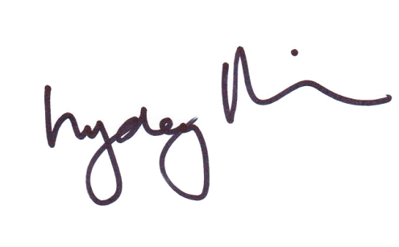

Lyndey Milan OAM